Day-3 Assignment
Q1. Create a comparison table listing the main differences between DDR3, DDR4, and DDR5 RAM, including speed, voltage, and typical use cases.
Ans.
DDR3 vs. DDR4 vs. DDR5 Comparison Table :
Feature | DDR3 | DDR4 | DDR5
Release Year | 2007 | 2014 | 2020
Speed / Transfer Rate | 800 to 2133 MT/s | 1600 to 3200+ MT/s (up to 5100+ MT/s overclocked) | 4800 to 8400+ MT/s
Operating Voltage | 1.5V (Standard) / 1.35V (Low-Voltage) | 1.2V (Standard) / 1.05V (Low-Voltage) | 1.1V (Base, with on-module PMIC)
Max Module Capacity | Up to 16GB per DIMM | Up to 64GB per DIMM | Up to 128GB+ per DIMM
Channel Architecture | Single 64-bit channel per module | Single 64-bit channel per module | Dual independent 32-bit sub-channels per module
Error Correction | None (External ECC variants for servers only) | Standard on-board or server-grade ECC | On-die ECC built directly into every consumer module
Typical Use Cases | Legacy systems, older office desktops, budget secondhand builds | Mainstream older-gen gaming PCs, mid-range office machines | High-end gaming rigs, 4K video editing, 3D rendering, modern workstation and server workloads

Q2. Open your laptop or desktop (with power disconnected), locate the RAM slots, and take a clear photo of the installed RAM module. Reinstall the RAM module and verify that your system boots up successfully. Refer to your device manual or a trusted YouTube guide if unsure about RAM removal and installation steps.
Ans.
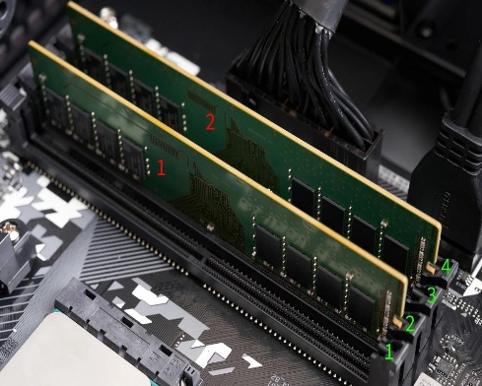
Step 1: Switch off the computer
- Shut down your laptop or desktop.
- Disconnect the power cable and all peripherals.
- For a laptop, follow the manufacturer's instructions for disconnecting the internal battery, if accessible.
- Touch an unpainted metal surface to reduce static electricity.
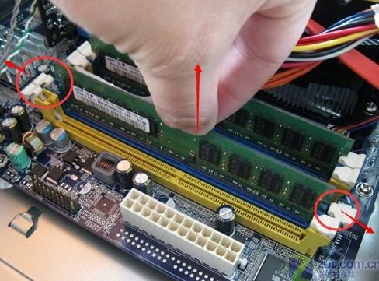
Step 2: Locate the RAM module
- Open the computer case or the laptop's service panel.
- Identify the RAM slots on the motherboard.
- Take a clear photo of the installed RAM before removing anything.

Step 3: Remove and inspect the RAM
- Release the retaining clips gently, if your RAM slot uses them.
- Hold the RAM module by its edges.
- Check the module for its capacity, label, and visible damage.
- Avoid touching the gold contacts.
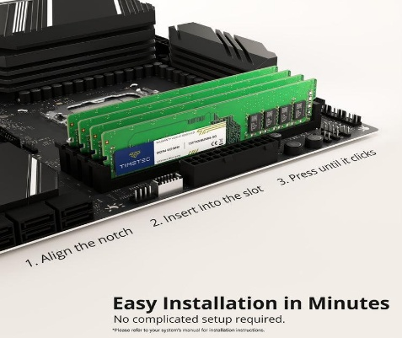
Step 4: Reinstall the RAM
- Align the notch in the RAM module with the slot.
- Insert it evenly and press gently until the retaining clips secure it.
- Close the case and reconnect the power.
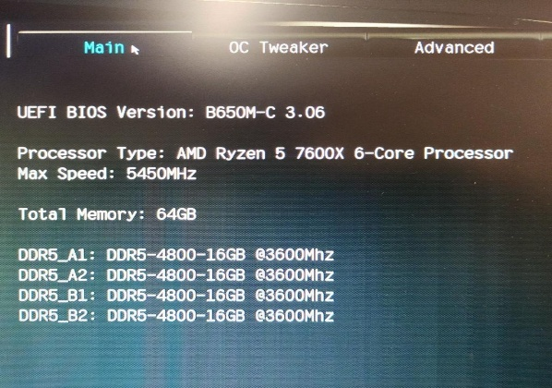
Step 5: Verify successful boot
- Turn on the computer.
- Confirm that it starts normally and loads Windows.
- In Windows, open Task Manager → Performance → Memory.
- Check that the installed memory capacity is detected.
Q3. List three key differences between HDD, SSD, and NVMe storage types, and for each, name one app or use case (from apps you use daily) that would benefit most from that storage type.
Ans.

Feature | HDD (Hard Disk Drive) | SATA SSD | NVMe (Non-Volatile Memory Express)
Underlying Technology | Mechanical spinning magnetic platters and read/write heads | Flash memory (NAND) connected via SATA interface | Flash memory (NAND) connected directly to PCIe lanes
Sequential Speed | ~80 to 160 MB/s | ~500 to 550 MB/s (capped by SATA III limit) | ~3,500 to 7,000+ MB/s
Primary Advantage | Lowest cost per gigabyte for massive data storage | Significant speed boost over HDDs for older systems | Maximum throughput, near-instantaneous file access, ultra-low latency

Q4. Remove the storage drive (HDD or SSD) from your system, take a photo of the connector type (SATA, M.2, or NVMe), and reinstall the drive. Confirm that your device recognizes the storage after reassembly. Only perform this task if you have access to a device you are allowed to open. If not, find and share a YouTube video link showing the process for your laptop/PC model.

Ans.
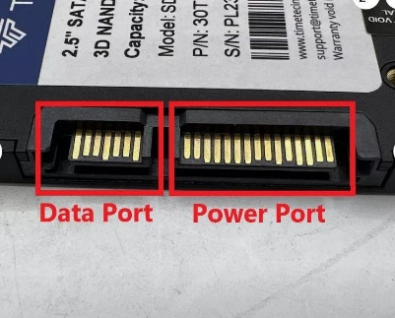
1. Power off the computer
Shut down the system, disconnect the charger and peripherals, and follow the manufacturer's battery-disconnection instructions. Use an anti-static precaution.
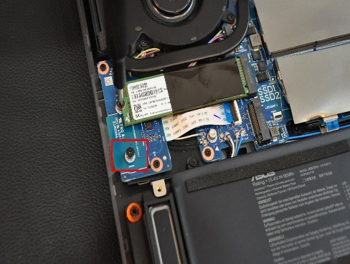
2. Locate the storage drive
Open the service panel according to the device manual. Identify the HDD or SSD and take a clear photo of its label and connector before removing it.
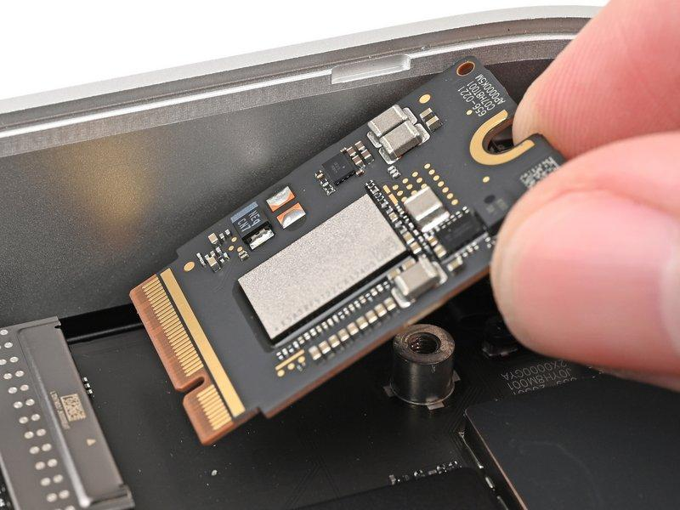
3. Remove and identify the drive
Disconnect it gently. For an M.2 drive, remove its retaining screw and allow it to lift at an angle before sliding it out. Photograph the connector and drive label.
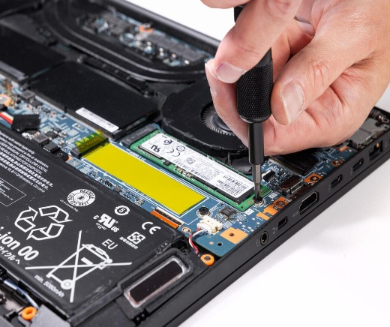
4. Reinstall the drive
Reconnect the drive carefully, secure it with the correct screw or bracket, and reassemble the device. Never force a connector.
5. Verify that the storage is recognized
After reassembly:
- Turn on the computer and check whether Windows starts normally.
- Open Task Manager → Performance → Disk.
- Alternatively, right-click Start and open Disk Management to check the drive.
- If Windows does not start, check whether the drive appears in BIOS/UEFI. Do not format or initialize a drive if it contains important data.

